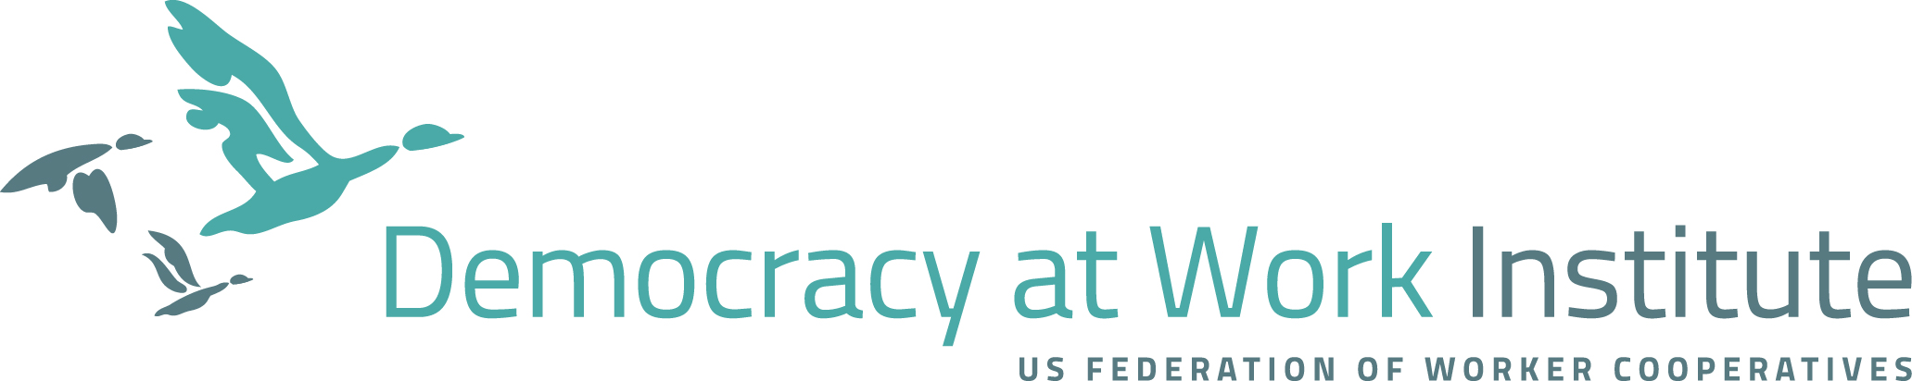

Ecosystem Assessment Tool Guide

The Cooperative Growth Ecosystem Framework describes what is needed for worker cooperatives to thrive and scale in any community. The Democracy at Work Institute and Project Equity developed this framework after analyzing various cooperative ecosystems in the United States and around the world. They found that all ecosystems have key elements that interact either to support or inhibit the growth of worker cooperatives.

The Cooperative Growth Ecosystem organizes these elements into three major categories. Essential Elements are the building blocks of cooperative businesses and the engines for growth; neither impact nor scale can be achieved without them. Important Elements accelerate growth and can be key drivers for scaling cooperatives. Environmental Elements legitimize and create demand for worker cooperatives, but do not directly support growth or scale.

Using this Framework, we can analyze any ecosystem’s strengths and gaps and identify what elements we might leverage to build and grow the worker cooperative sector.

The Ecosystem Assessment Tool

The Ecosystem Assessment Tool helps you analyze the ecosystem elements in your community by ranking existing relationships, current infrastructure, prevailing culture, and available resources. By assigning a score for each element, this Tool will then generate a bubble chart indicating the relative strengths and gaps of your ecosystem.

No community is the same, and no community has the perfect conditions in place for worker cooperatives (yet). Each community will have a different set of opportunities and intervention points. The purpose of this analysis is for you to see how you might leverage your strengths and resources to build out the missing Essential, Important, and Environmental elements. Our intention is that you are able to identify –based on your knowledge of local issues, economic drivers, and the political environment— what might be the game-changers for worker cooperative growth.

For a deeper insight into how this framework was developed, we recommend reading the Cooperative Growth Ecosystem report written by the Democracy at Work Institute and Project Equity.

How to use the tool
The Ecosystem Assessment tool has three tabs: Essential Elements, Important Elements, and Environmental Elements. Start with the Essential Elements tab. For each element, choose the most accurate description of your ecosystem and type it’s corresponding rank into the yellow box labeled “Your Rank”. As you choose the descriptions that best match the conditions of your ecosystem, you will see the bubble chart at the top of the tool change in response to your choices.
Analyzing your results
When you finish ranking each element, you will have generated a bubble chart map of your ecosystem’s assets and gaps. Each bubble represents an element: the bigger the bubble, the stronger that element is in your ecosystem.

Once you have a clear picture of the resources and capacities that exist, you can then determine which of these you can leverage to fill some of the gaps that are preventing or slowing worker cooperative development and growth. Each element represents individuals, communities, and organizations with whom you can build relationships. Ultimately, the bubble chart can show you how the greater ecosystem of business support organizations, policymakers, financial institutions, universities, and community groups might support worker ownership.

The following questions can help you analyze your results, identify groups to work with, and set initial targets for developing your ecosystem:

- What do the highest scoring elements say about your ecosystem? Was there anything illuminating or surprising about your analysis?

- What missing elements need to be addressed at this stage? Why?

- How can you leverage your ecosystem’s strengths to develop this capacity?

- What role do you play in this ecosystem? What are your goals for strengthening and growing worker cooperatives?

- What do you know about your ecosystem’s economic drivers, community issues, and political environment? What organizations and coalitions are leading this work? How does change happen at the community and government levels?

- What potential partnerships could you build to address some of these gaps? What role do these organizations play and what are their purposes, impact, and relationships to you and other key actors in your ecosystem?

- Based on your analysis, what would be a game-changer in your ecosystem? Why?

- What is your next step? What are your goals and how will you know you are making progress?

The Democracy at Work Institute can support you to develop your ecosystem strategy. For an initial consultation, please contact Zen Trenholm at ztrenholm@institute.coop

We have developed a tool to help you analyze actors for alignment and build successful partnerships.

